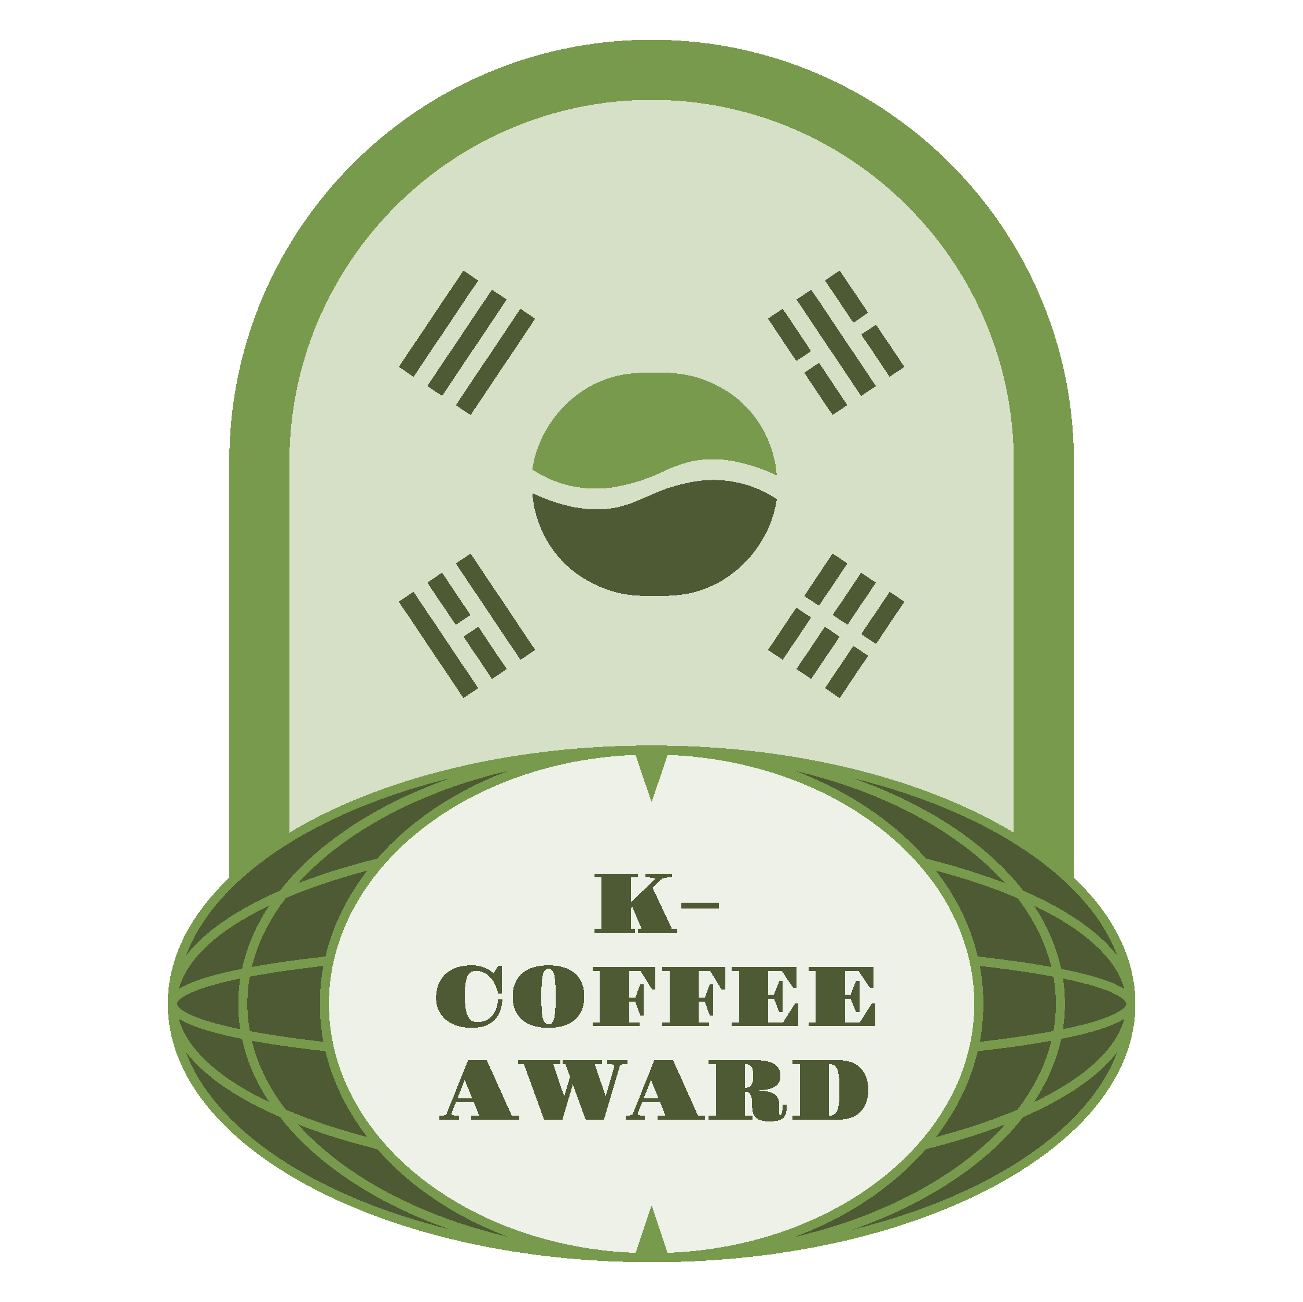 | 2026 K-COFFEE AWARD · SUMMER-FALL SEASON  GREEN COFFEE ENTRY APPLICATION FORM  THE BEST GREEN BEANS AND COFFEE FARM | 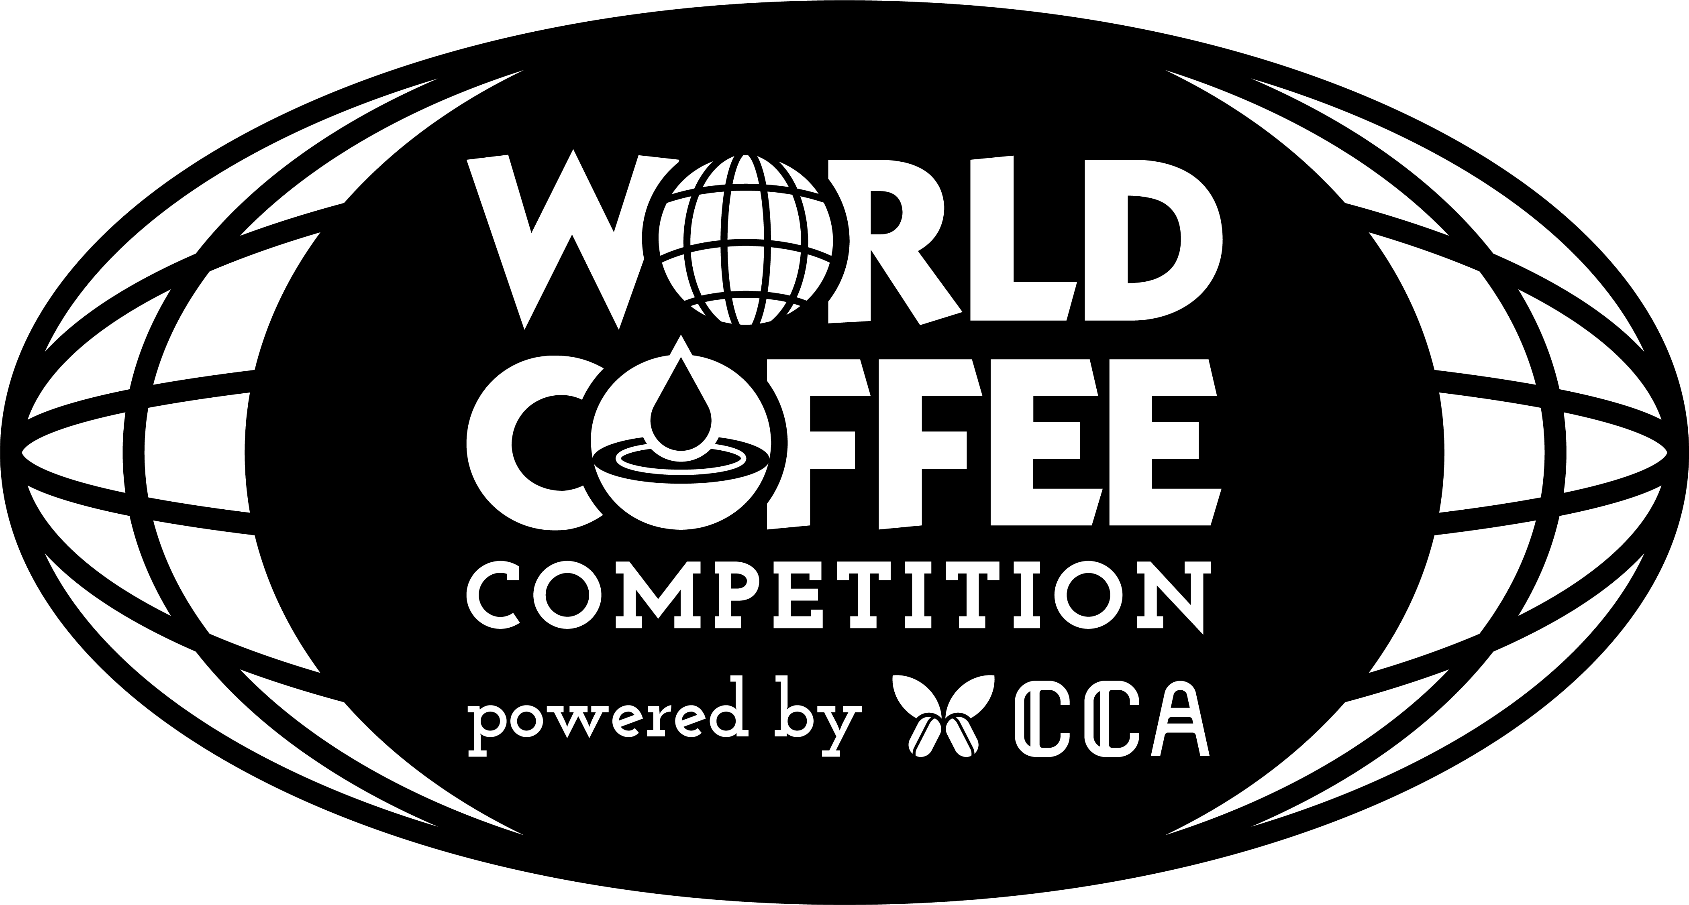

INSTRUCTIONS Items 1-10 are mandatory and must be submitted with the green coffee entry.
Delete the gray instructional text and enter your information directly in this Word document. Fields and pages may expand as needed.
01 APPLICANT INFORMATION
Applicant's Full Name | Enter the applicant's full name.
Organization | Enter the company, institution, farm, cooperative, or other affiliation.
Contact Information | Enter a telephone number and/or email address.

02 PROPOSED SALE PRICE FOR THE SUBMITTED GREEN COFFEE
Sale Price Offered to the Organizing Committee  Based on the submitted green coffee | Enter the proposed price. | KRW/kg
03 GREEN COFFEE INFORMATION Items 1-3
1 | Processing Method  Specify the actual processing method applied | e.g., Washed, Natural, Honey or Pulped Natural, Other
2 | Production Origin  (Country / Specific Region)  List the country and detailed origin in order | e.g., Country / State, Province, or Region / Village or Production Area
3 | Producer / Farm  Provide both the producer's name and the farm name | Producer's Name / Farm Name

2026 K-COFFEE AWARD | SUMMER-FALL SEASON
GREEN COFFEE INFORMATION
Required Items 4-10 of the 10 mandatory information fields.
03 GREEN COFFEE INFORMATION Items 4-10
4 | Cooperative Name  Complete if applicable | Enter the cooperative name or 'Not applicable.'
5 | Variety / Genetic Group  State the variety name or known genetic group | Enter the variety or genetic group.
6 | Growing Elevation  State the elevation or range in metres above sea level | e.g., 1,700-1,900 m a.s.l.
7 | Harvest Period  State the year and month | YYYY-MM to YYYY-MM
8 | Harvesting Method  Specify the actual coffee cherry harvesting method | e.g., Selective hand-picking, strip-picking, mechanical harvesting
9 | Coffee Cultivation Area  State the area and unit of measurement | e.g., 12 ha
10 | Annual Production Volume  State the quantity and unit of measurement | e.g., 25,000 kg or 25 metric tons
COMPLETION STANDARD Include units with all numerical values. If information is unavailable or an item does not apply, enter 'Information not available' or 'Not applicable.'

2026 K-COFFEE AWARD | SUMMER-FALL SEASON
ADDITIONAL INFORMATION
Please answer the questions below.
04 CERTIFICATIONS AND GREEN COFFEE PROFILE
1 | Certification Status (List all certifications applicable to the submitted green coffee, including organic and fair trade certifications.)
 | Enter the certification name, certifying body, certificate or registration number, validity period, and other verifiable details. If none apply, enter 'Not applicable.'

2 | Provide any additional information about the submitted green coffee.
 | Describe the production environment, producer background, variety and processing characteristics, sustainability initiatives, or any other information that may assist in understanding the entry. Expand this field if necessary.
PRE-SUBMISSION CHECK ☐ Items 1-10 completed ☐ Proposed price entered ☐ Narrative responses reviewed

